**SOCIAL MEDIA COURSEWORK  
Margot robbıe**

|  |
| --- |
| *Hasan E. Guray* |
|  |
| MSc Data Science and Analytics student |
| University of Westminster |
| w1948912@my.westminster.ac.uk |

ABSTRACT

This research paper presents a case study focused on analysing public perceptions of Margot Robbie after her latest movie Barbie release date. Leveraging a dataset comprising 1633 Reddit comments, the study delves into five primary discussion topics and employs three distinct sentiment analysis methods to gain comprehensive insights. The findings shed light on the sentiment surrounding the actress's portrayal and offer valuable implications for understanding audience reception in the film industry.

**Keywords:** Margot Robbie, Barbie film, Reddit comments, Sentiment analysis, Topic modelling.

# PERSON SELECTED

Margot Elise Robbie, a renowned Australian actress, and producer, was born on July 2, 1990, in Australia. Following her completion of drama studies at Somerset College, she embarked on her professional acting career at the age of 17 and relocated to Melbourne to pursue her artistic passion. Alongside her acting success, Margot Robbie's influential standing was widely acknowledged, with Time magazine including her in its list of the "World's 100 Most Influential People" in 2017, and Forbes recognizing her as one of the highest-paid actresses in 2019. Furthermore, she demonstrated her versatility and impact as a producer through her company, LuckyChap Entertainment.

Recently, Margot's popularity soared due to her role in the 2023 American fantasy comedy film "Barbie." Directed by Greta Gerwig and co-written with Noah Baumbach, the movie features Margot Robbie as Barbie and Ryan Gosling as Ken, marking the first live-action adaptation of the iconic fashion dolls by Mattel. The plot centers around a journey of self-discovery prompted by an existential crisis. The film boasts an ensemble cast, including America Ferrera, Kate McKinnon, Issa Rae, Rhea Perlman, and Will Ferrell. "Barbie" premiered on July 9, 2023, in Los Angeles and experienced a successful theatrical run, grossing over $578 million worldwide, thus becoming the eighth highest-grossing film of 2023.

# Data COLLECTION

In the present era characterized by technological advancements, the rapid dissemination of information and ideas has become notably accelerated, with social media playing a significant role in facilitating this process. Numerous social media platforms offer a virtual space where users can freely exchange ideas and engage with one another. To conduct an in-depth analysis of Margot Robbie's public perception and assess her recent professional accomplishments, Reddit, a platform known for its free API support and substantial user traffic, was employed to establish the dataset.

Reddit has gained substantial popularity, ranking as the 10th most visited website globally, as indicated by data from June 2023 (https://www.semrush.com/website/top/ accessed on 29 July 2023). To capture the most relevant data for analysis, the date range of 21st to 27th July 2023 was selected, aligning with the release date of the film and focusing on the ensuing one-week period to observe the impact of its recent surge in popularity. Python's pandas, praw, and datetime libraries were utilized to extract and compile a comprehensive dataset of 1633 comments (Figure 1), leveraging Reddit's API support.

By leveraging this dataset, researchers can delve into the perceptions and discussions surrounding Margot Robbie's recent work and gauge the sentiment and popularity of her projects within the Reddit community during the specified time frame. The abundance of user-generated content on Reddit offers valuable insights into the reception of her performances and provides a unique opportunity for data-driven analysis in the realm of data science.

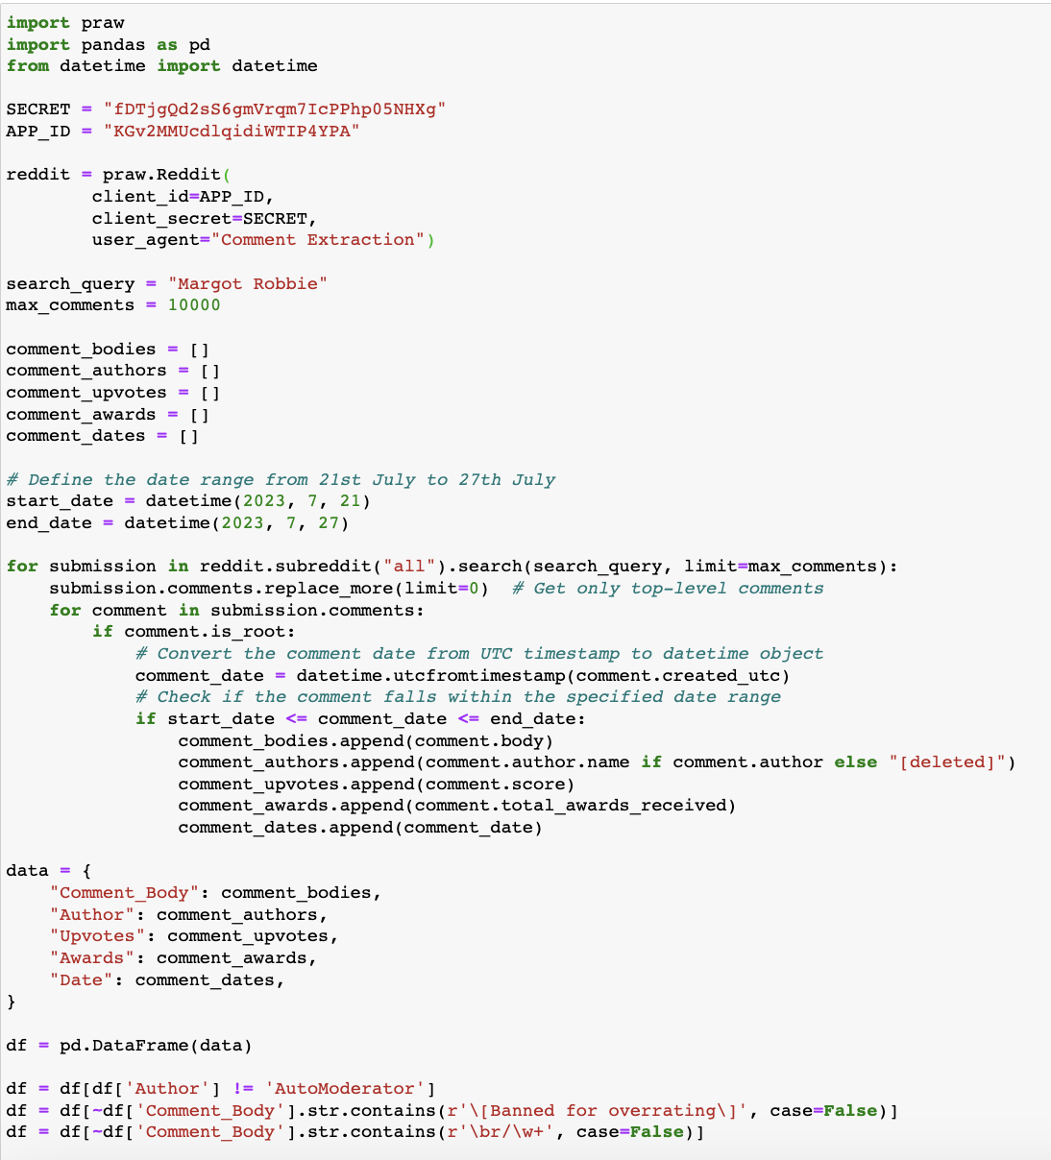

**Figure 1** *This is a screenshot of Python code to scrape Reddit comments about Margot Robbie.*

In order to mitigate potential dataset ambiguity arising from user-to-user interactions, exclusively top-level comments were focused. Moreover, to ensure data integrity, certain comments, namely those auto-generated by the system and those intended for specific users, were excluded from the analysis. As a consequence of these filtering measures, a comprehensive dataset was constructed, encompassing pertinent attributes such as "Comment Body" to encapsulate the comment content, "Author" denoting the user responsible for the comment, "Upvotes" and "Awards" to account for interactions received by the comment, and "Date" indicating the precise timestamp of comment dissemination on the platform (Figure 2).

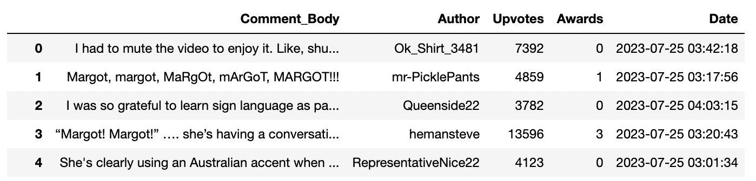

**Figure 2** *This is a screenshot of Pandas dataframe, consists Reddit comments about Margot Robbie.*

Undoubtedly, given the unprocessed nature of the dataset, replete with raw user-generated comments, it is imperative to undertake diligent data cleaning and pre-processing before commencing the exploratory data analysis phase. Consequently, during the examination of the dataset, the initial pre-processing step involved the conversion of the "Date" column into the datetime format (Figure 3). This conversion rendered the temporal information amenable to subsequent analytical procedures.

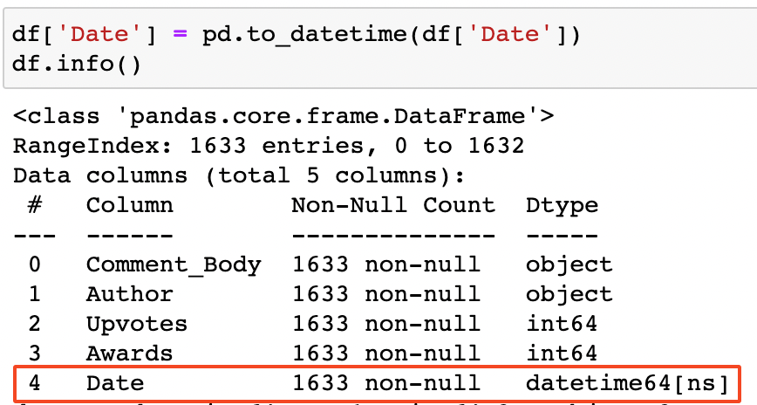

**Figure 3** *This is a screenshot of Pandas dataframe’s column details, consists Reddit comments about Margot Robbie.*

To optimize the efficacy of topic model analysis and sentiment analysis procedures, it is essential to subject the raw comments to preparatory steps. In this context, Python's contractions library was employed to standardize the comments, effectively resolving contractions within the text and thereby facilitating a more coherent representation (Figure 4). By executing this pre-processing operation, the comments became suitably prepared for subsequent analytical operations, enhancing the overall success of the topic model and sentiment analysis processes.

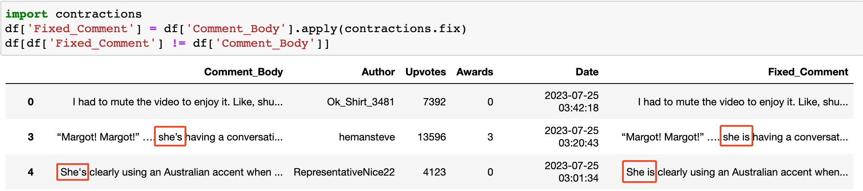

**Figure 4** *This is a screenshot of a Python formula to fix contractions.*

Subsequently, to ensure uniformity in the analytical treatment of textual content, Python's "re" library was leveraged to standardize words encompassing price, size, volume, and weight attributes (Figure 5). By accomplishing this standardization, the potential disparity arising from disparate numerical representations was effectively mitigated, safeguarding the consistency and integrity of the subsequent analyses.

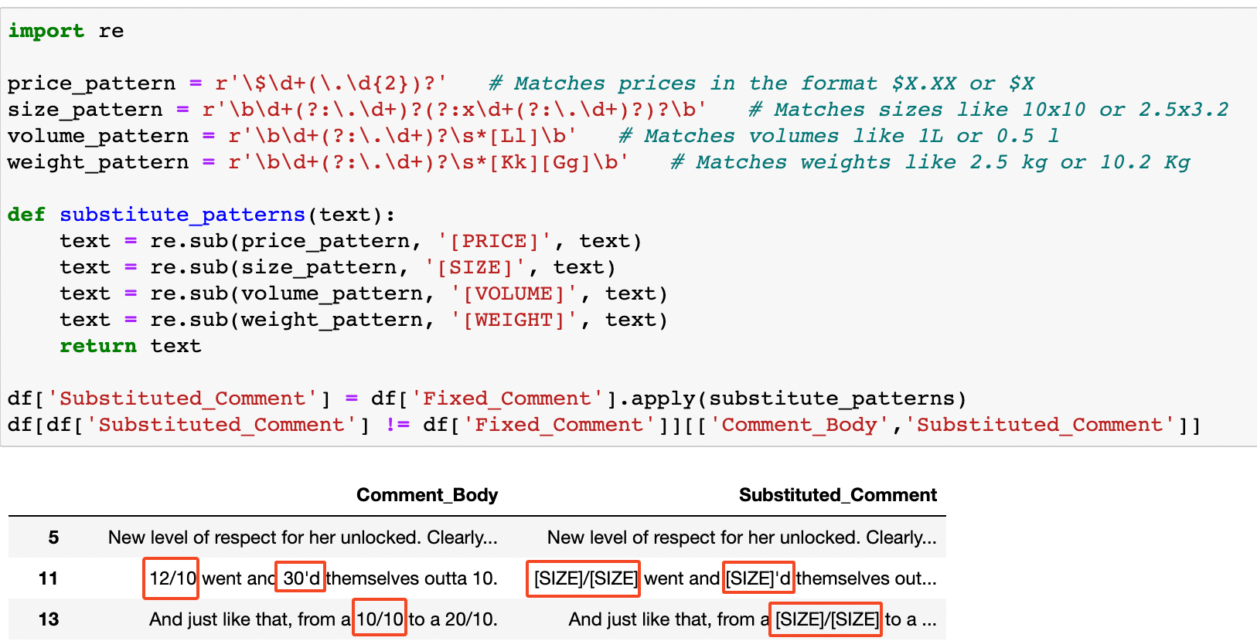

**Figure 5** *This is a screenshot of a Python formula to substitute patterns.*

Within the corpus of comments, a notable presence of hyperlinks has been observed, serving the purpose of guiding users to external online resources. The inclusion of such links can serve various functions, ranging from explanatory or supportive references to instances of humorous commentary. In the interest of enhancing the efficacy of the analyses, it becomes imperative to standardize these hyperlinks, consolidating them under a singular category. To this end, the "re" library in Python is harnessed to effectively aggregate the links and establish a coherent representation (Figure 6). By undertaking this standardization process, the analyses stand to benefit significantly, ensuring greater consistency and interpretability throughout the investigative endeavours.

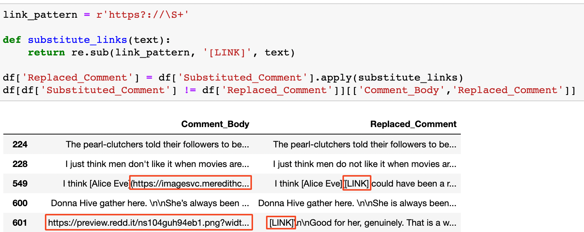

**Figure 6** *This is a screenshot of the Python formula to replace http links.*

While navigating the Reddit platform, the occurrence of the "\n" expression is not apparent. However, it has come to light that certain comments within the scraped dataset employ this expression as a representation of line transitions. To rectify this extraneous presence and foster a more streamlined data representation, Python's "replace" formula was employed (Figure 7). Through this process, these inconsequential expressions were effectively expunged, resulting in a more coherent and structured dataset, thus facilitating subsequent analyses with greater precision and clarity.

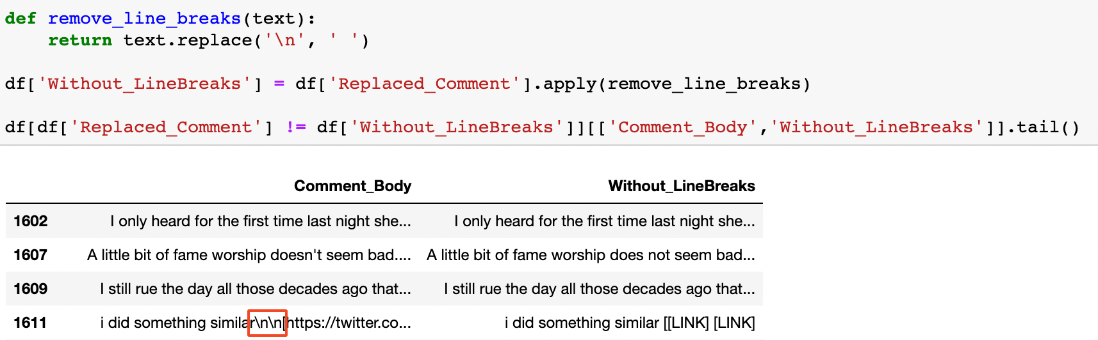

**Figure 7** *This is a screenshot of the Python formula to remove line breaks.*

Various factors, such as hurried composition, social media-specific abbreviations, and other contributing sources, contribute to the prevalence of typographical errors in the comments. Left unaddressed, these inaccuracies have the potential to jeopardize the veracity of analytical outcomes. To rectify these issues, the utilization of Python's TextBlob library enables the correction of misspellings and the standardization of words sharing a common root. Nonetheless, it is crucial to exercise caution in processing entire comments collectively, as such an approach can inadvertently render certain accurate words erroneous (Figure 8).

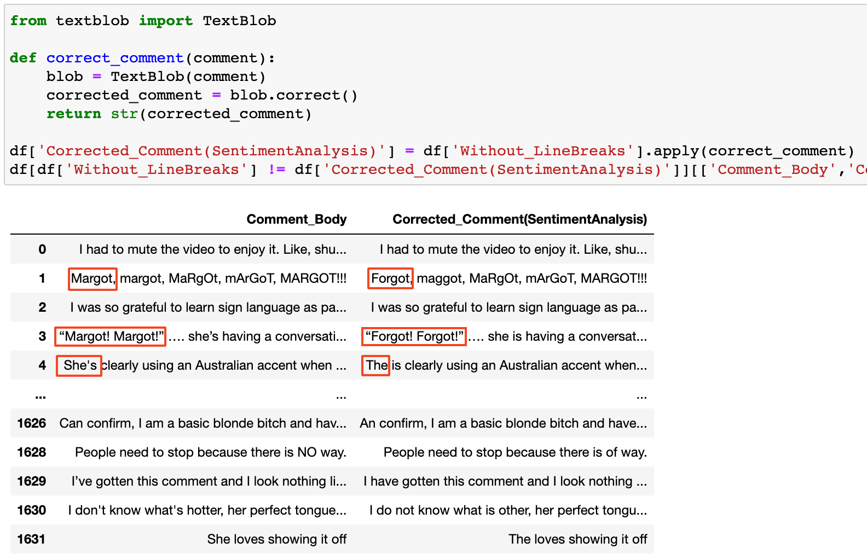

**Figure 8** *This is a screenshot of the Python formula to correct the words.*

To mitigate this challenge, a more meticulous approach was adopted, wherein mistranslated words were identified before subjecting the words individually through the TextBlob library (Figure 9). This refined methodology yielded more precise and reliable results, circumventing the risk of false corrections and enhancing the overall accuracy of the analyses.

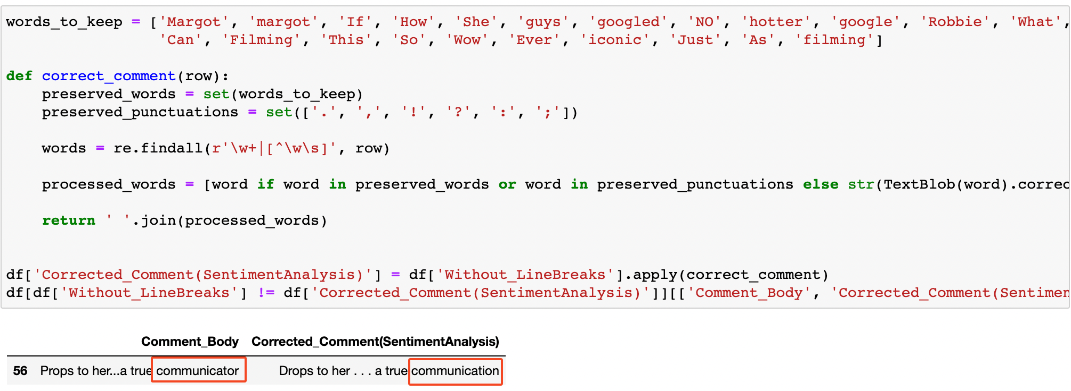

**Figure 9** *This is a screenshot of the Python formula to correct the words.*

In pursuit of optimizing the efficacy of topic model analysis, comprehensive standardization assumes paramount importance. To this end, an essential pre-processing step involves the conversion of all letters in the comments to lowercase, thereby enhancing uniformity and consistency. Employing Python's "lower()" formula, this operation was effectively carried out (Figure 10).

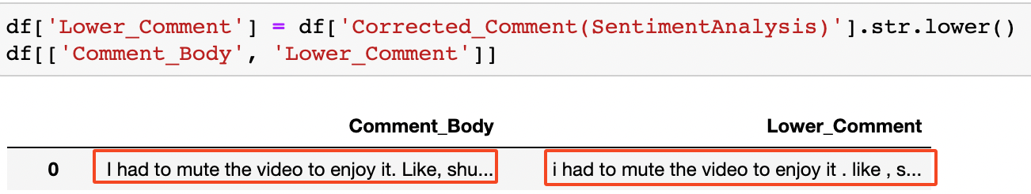

**Figure 10** *This is a screenshot of the Python formula to convert to lowercase all of the letters.*

However, it is noteworthy that the distinction between uppercase and lowercase letters holds particular significance in sentiment analysis. This aspect serves to convey diverse emotional states or to accentuate emotional emphasis. Consequently, it is judicious to exercise caution, and, thus, the application of lowercase transformation and related pre-processing steps are judiciously withheld from sentiment analysis and subsequent stages.

An additional instrumental procedure that significantly enhances the efficacy of the topic model analysis pertains to tokenization. Tokenization represents a pivotal phase in the preparatory treatment of textual data for topic model analysis. This crucial process facilitates the conversion of unstructured text into a structured framework, thereby enabling topic modelling algorithms to discern underlying patterns and extract coherent topics of significance. Through the standardization of word representations and the removal of extraneous noise, tokenization substantially elevates the accuracy and interpretability of the topic modelling process.

In this context, the implementation of tokenization was accomplished utilizing Python's "nltk" library (Figure 11). The application of this natural language processing tool empowered the segmentation of textual content into discrete tokens, aligning with the data pre-processing requirements of topic modelling, and ultimately fostering a more robust and informative analytical outcome.

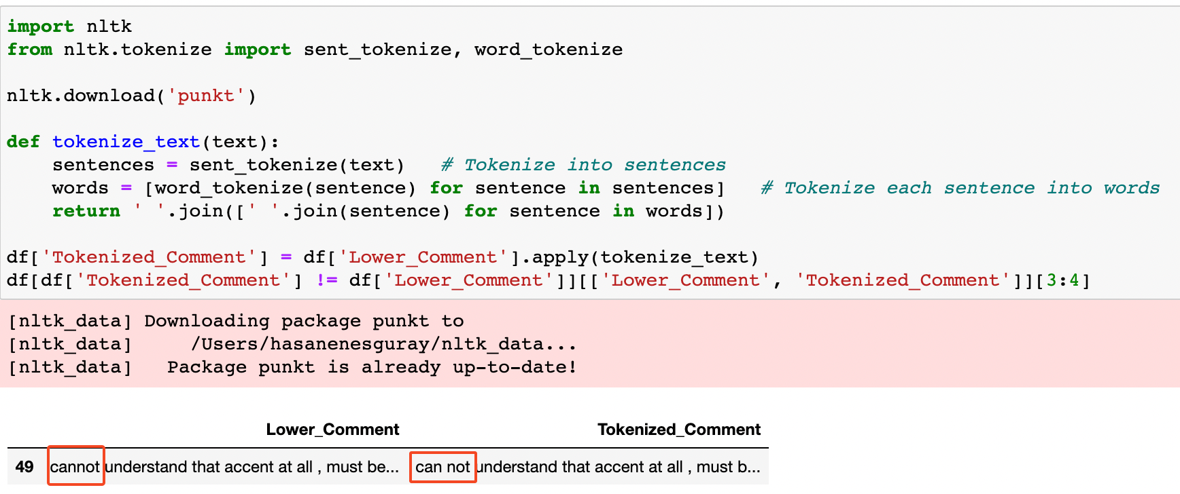

**Figure 11** *This is a screenshot of the Python formula to convert to tokenize the words.*

The exclusion of stopwords, which are function words devoid of substantive meaning on their own, constitutes an essential endeavour in topic model analysis. By eliminating these commonly occurring, non-informative words, the influence of such extraneous terms is mitigated, thereby enhancing the identification and comprehension of meaningful patterns within the text. This pre-processing step significantly augments the overall quality and interpretability of the derived topics by ameliorating noise levels, enhancing topic coherence, and channelling the model's attention towards more pertinent and distinctive terms.

To effectuate this critical task, Python's "nltk" library was harnessed (Figure 12). The utilization of this natural language processing resource facilitated the systematic removal of stopwords, aligning with the tenets of data refinement requisite for proficient topic model analysis. Consequently, this operation enabled the extraction of more refined, insightful, and coherent topics, amplifying the discernibility of underlying structures and insights present within the textual corpus.

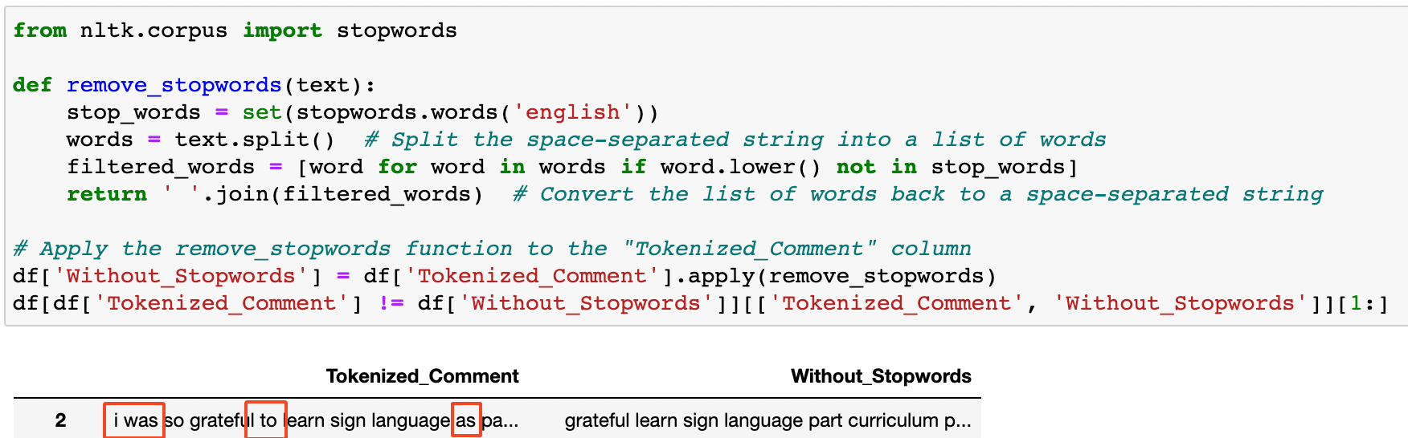

**Figure 12** *This is a screenshot of a Python formula to remove stopwords.*

Of paramount significance within comments are emojis and punctuation marks. In the context of topic model analysis, their removal assumes indispensable importance as it serves to alleviate noise, enhance coherence, and elevate the interpretability of the resulting topics. By expunging emojis and punctuation marks, a refined and standardized textual representation is attained, focusing attention on the salient lexical content, mitigating dimensionality, and cultivating a cleaner data format conducive to efficient and precise topic modelling.

To effectuate this vital pre-processing task, the Python "re" and "string" libraries were judiciously employed (Figure 13). Through the strategic application of these libraries, emojis and punctuation marks were systematically deleted, aligning with the data refinement requisites essential for rigorous topic model analysis. Consequently, this preparatory operation not only fostered a more discerning identification of meaningful lexical elements but also contributed to the establishment of a robust and amenable foundation for the extraction of insightful and coherent topics from the textual corpus.

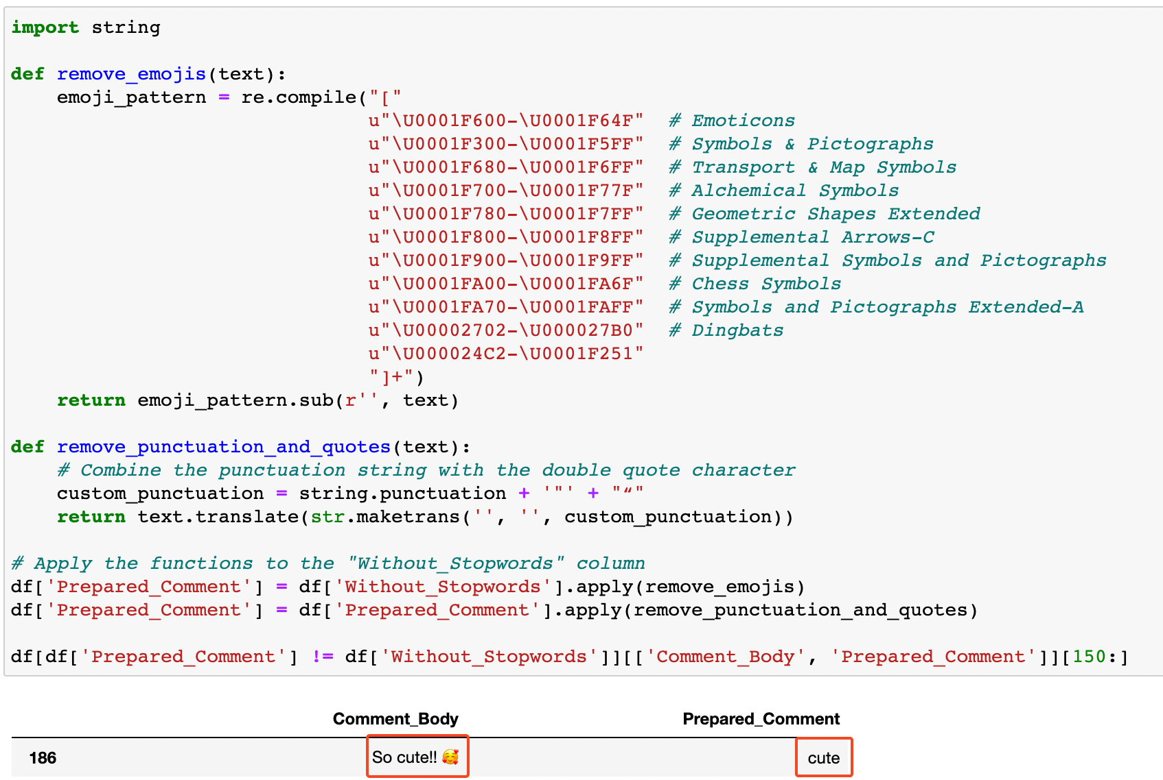

**Figure 13** *This is a screenshot of a Python formula to remove punctuations and emojis.*

Lemmatization constitutes a pivotal pre-processing phase in topic model analysis, bearing remarkable value in the normalization of words to their base forms while consolidating various inflected word variations. This transformative process yields substantial improvements in the interpretability and coherence of the text, while concurrently reducing the dimensionality of the vocabulary. As a result, lemmatization fosters the generation of more meaningful and efficient topic modelling outcomes, faithfully capturing the essence of the data's core themes with heightened precision.

The implementation of lemmatization realized through Python's "nltk" library, embodied a potent means to accomplish this essential data refinement task (Figure 14). By capitalizing on the linguistic insights afforded by the "nltk" library, lemmatization profoundly influences the topic model analysis, facilitating a more sophisticated and nuanced understanding of the underlying semantic structures. In turn, this contributes significantly to the pursuit of more robust, informative, and insightful topic modelling outcomes that resonate coherently with the textual corpus at hand.

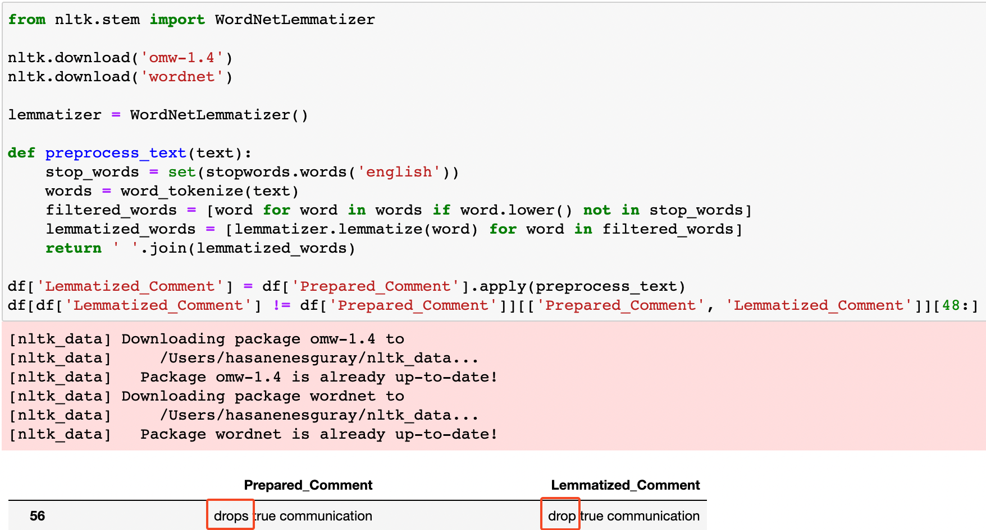

**Figure 14** *This is a screenshot of the Python formula for lemmatisation.*

To ensure analytical integrity and mitigate complexity arising from redundant data, it is imperative to expunge duplicate entries, particularly identical comments from the same users. This de-duplication process is essential to maintain data coherence and prevent undue influence on the analysis. Leveraging Python's "drop_duplicates()" function, the issue of duplicates was effectively circumvented (Figure 15).

Through the implementation of this function, duplicate instances were efficiently identified and removed, thus fostering a more streamlined and unambiguous dataset. By undertaking this preparatory step, the risk of inflated influence or skewed representation of certain comments was averted, rendering the ensuing analysis more robust and trustworthy. The exclusion of duplicates engendered enhanced data quality and contributed to the generation of more accurate and credible insights in the context of the data science investigation.



**Figure 15** *This is a screenshot of the Python formula to remove duplicates.*

Following the comprehensive data cleaning and pre-processing procedures, certain comments were identified to be entirely devoid of meaningful content and were subsequently rendered as "na" values. To ensure the dataset's integrity and to obviate the influence of these empty entries on subsequent analyses, Python's "dropna()" function was diligently employed (Figure 16).

Through the application of this function, all instances containing "na" values were expunged, thereby refining the dataset and purging it of any remaining vestiges of uninformative or incomplete data. This judicious step contributed to the generation of a more robust and reliable dataset, free from any spurious or misleading information. By removing the "na" data, the analytical procedures stood to yield more accurate and insightful outcomes, unencumbered by the presence of extraneous or erroneous entries.

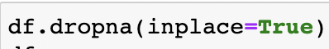

**Figure 16** *This is a screenshot of the Python formula to remove na records.*

The linguistic composition of comments plays a decisive role in the analysis, as the analytical procedures are tailored to a specific language context. Given the prevalence of English as the predominant language, the removal of non-English records proves imperative to engender more efficacious results. Consequently, the dataset was meticulously purged of non-English comments, a process executed via the Python "langdetect" library, resulting in the retention of 1105 rows of data (Figure 17).

By detecting and eliminating non-English content using the "langdetect" library, the dataset became more homogenous and amenable to the intended analysis, fostering enhanced analytical outcomes that align with the prescribed linguistic focus. This data refinement endeavour ensured that the subsequent analyses were conducted within a coherent language context, obviating the confounding effects of language diversity, and rendering the conclusions more robust and relevant within the purview of the data science exploration.

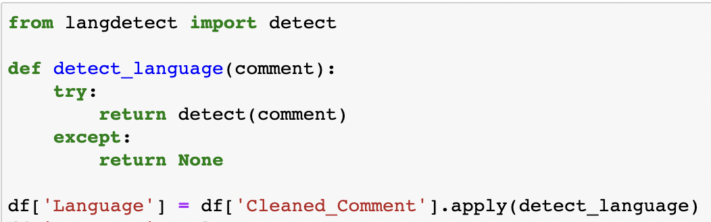

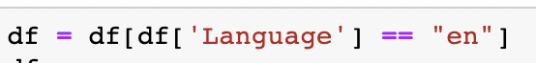

**Figure 17** *This is a screenshot of the Python formula to keep just English comments.*

# EXPLORATORY ANALYSIS

For data acquisition, a temporal window of one week was selected, commencing from the date of the Barbie movie's release. Within the dataset encompassing the period from 21st to 27th July 2023, a consistent daily influx of comments was observed, with a notable surge in comment activity on the 25th of July 2023 (Figure 18). It is noteworthy that, despite the movie's release on the 21st of July 2023, the volume of comments generated on that specific day did not attain a preeminent proportion in the overall dataset.

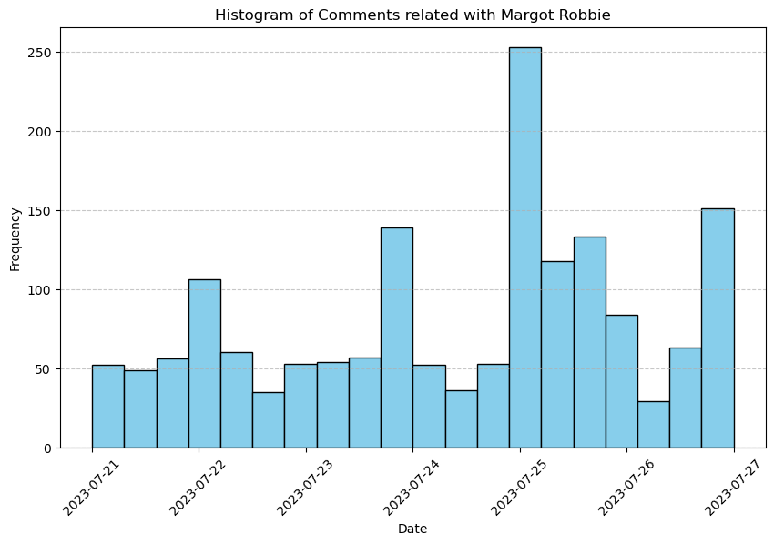

**Figure 18** *This is a histogram of the comments count related to Margot Robbie on Reddit.*

To enhance the efficacy of the analyses, it was deemed imperative to ascertain the presence of concentration among specific authors, as having diverse contributors for the comments would facilitate more robust conclusions. As part of this investigation, the distribution of comments across various authors was scrutinized. Remarkably, it was observed that the author with the highest comment count contributed merely 5 comments, thereby substantiating the heterogeneous nature of the dataset, emanating from distinct individuals' sentiments and viewpoints (Figure 19).

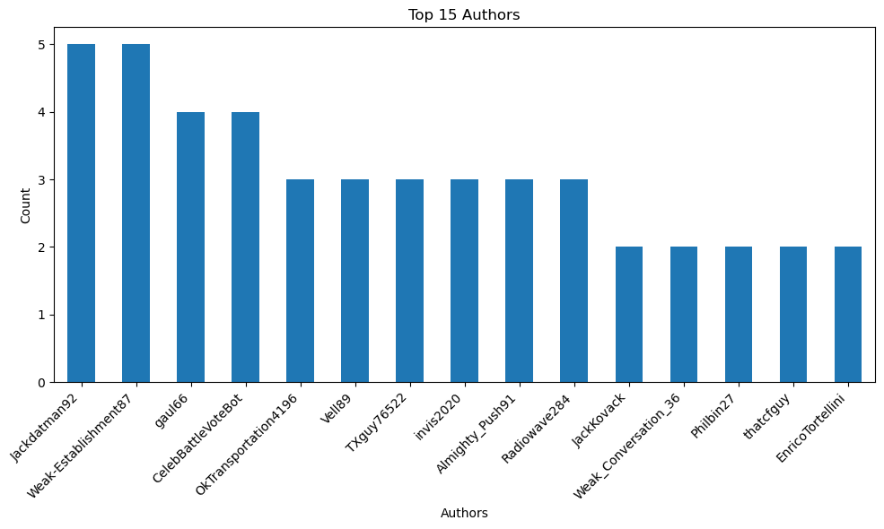

**Figure 19** *This is a bar graph of the comments count of the authors related to Margot Robbie on Reddit.*

Utilizing the upvotes and awards system as an interactive mechanism among users, an analysis was conducted on comments that garnered the most upvotes and awards. Among these, the comment contains the phrase " I learned some sign language in GATE as a kid, and eventually I had a deaf women come through my gas station. I signed the letters for "receipt", asking her if she needed one, and her eyes lit up, and I got a big grin, never gonna forget that interaction." attained the highest number of upvotes, amassing a total of 4524. Furthermore, a comment by the user SparklingLama, containing the phrase "I love how excited she looks" achieved one of the highest numbers of awards, securing one award within the context of the Reddit platform.

Given Reddit's global outreach, the dataset encompassed comments not only in English but also in diverse languages. In the examination of the language distribution, it was observed that 1105 comments were in English, constituting 69.6% of the entire dataset and occupying the foremost position. Subsequently, Afrikaans and French followed in prominence (Figure 20).

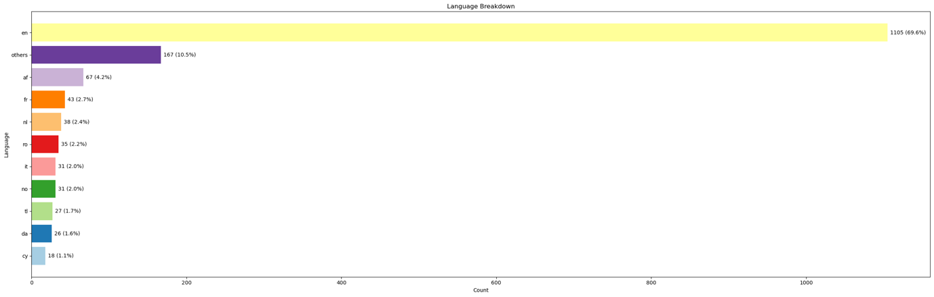

**Figure 20** *This is a bar graph of the comments count of the languages related to Margot Robbie on Reddit.*

Analysing the average comment length, English comments again emerged as the most extensive, with an average of 88.70 characters, while Italian ranked second with an average length of 36.16 characters (Figure 21).

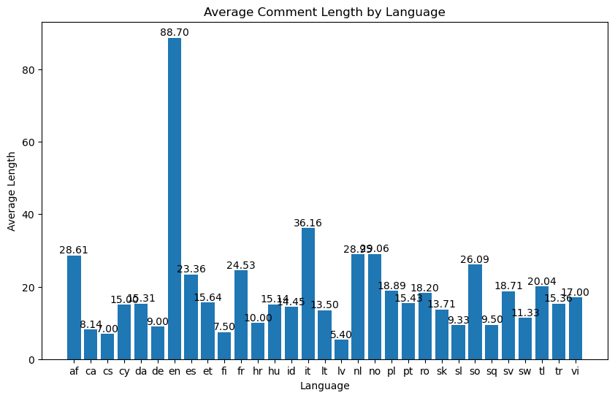

**Figure 21** *This is a bar graph of the average comment length of the languages related to Margot Robbie on Reddit.*

Conducting a comprehensive examination of term frequency during the initial stages of exploratory data analysis before undertaking sentiment and topic model analyses emerges as a pivotal step in comprehending data attributes, discerning prospective themes, and unearthing valuable insights into prevailing lexical usage patterns and emotional tendencies. This endeavour not only facilitates judicious decision-making concerning text pre-processing, feature selection, and data cleansing but also expedites the generation of a concise data synopsis and facilitates timely anomaly detection.

The salient findings derived from the term frequency analysis of the comments revealed the most recurrently employed words, namely "would," "like," "margot," "think," "size," and "movie," in descending order of prevalence. Notably, the term "size" assumes significance here, representing numerical expressions. Furthermore, within the corpus, the words "good," "woman," "great," and "role" were among the top 20 most frequently reiterated words. While the term "Barbie" did not emerge as the most common word in the comments, the word "movie" exhibited a notable prevalence.

Moreover, the most frequently recurring noun phrases encompassed "margot robbie," "great actress," "movie star," and "promising young woman," which underscore the profound admiration and luminous presence of Margot Robbie in her actress persona.

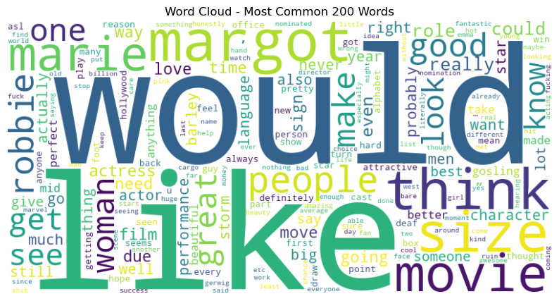

**Figure 22** *This is a wordcloud of the most common words in the comments related to Margot Robbie on Reddit.*

# TOPIC MODEL ANALYSIS

Topic modelling represents a pivotal approach for unearthing primary thematic patterns within Reddit comments datasets. By adeptly categorizing comments into coherent topics, it facilitates effective data exploration and comparative analysis. Nonetheless, its application entails certain drawbacks, such as contextual deficiency, potential topic ambiguity, and reliance on pre-processing methodologies. Augmenting topic modelling with sentiment analysis, employing diverse algorithms, and exercising judicious interpretation can substantially augment its efficacy in generating profound insights.

Latent Dirichlet Allocation (LDA) emerges as a widely adopted topic modelling technique for text data, owing to its capability to autonomously discover topics, yield coherent and interpretable thematic representations, and scale adeptly to handle extensive datasets. LDA's adaptability in controlling the number of derived topics and its pervasive integration within the domain of natural language processing further reinforce its popularity.

To cater to the appropriateness of the dataset and ensure sufficient capacity, LDA topic modelling, complemented by the support of Python's nltk and gensim libraries, was executed, resulting in the identification of five distinct topics (Figure 23).

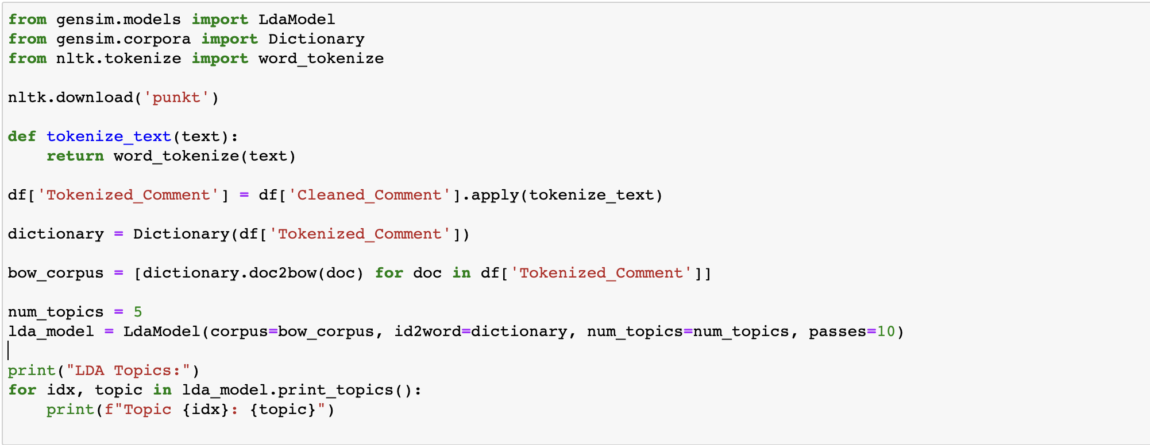

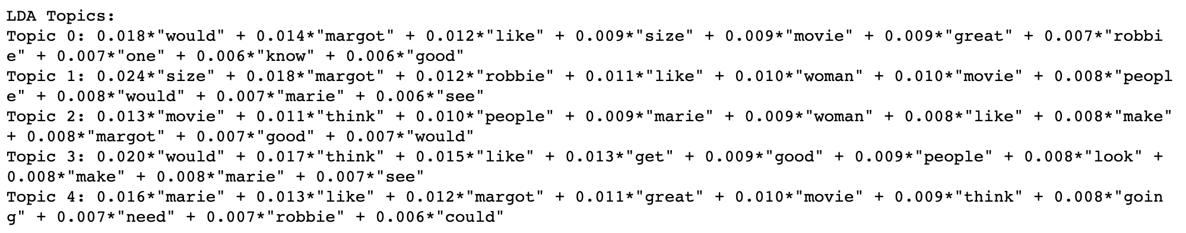

**Figure 23** *This is a Python code to build LDA topic modelling.*

Topic 0 exhibited discussions about Margot Robbie's performance or physical appearance, as evidenced by the presence of keywords such as "margot", "like", "size", and "movie". It was plausible that Reddit users were expressing their perspectives on her acting abilities or aesthetic attributes within the context of the latest cinematic production.

Topic 1 appeared to centre on Margot Robbie's portrayal of a specific character in the movie. The inclusion of terms like "size", "woman", and "movie" suggested dialogues concerning the character's role and impact within the cinematic narrative.

Conversations within Topic 2 seemed to revolve around the movie itself and its overarching influence on audiences. Keywords such as "movie", "think", and "people" implied comments about the film's plot, direction, or general reception among viewers.

Topic 3 appeared to involve deliberations regarding the movie's overall quality, as indicated by the presence of terms like "think", "good", "people", and "look". Users might be sharing their viewpoints on the movie's strengths and weaknesses.

Topic 4 was likely linked to a specific element or scene in the movie. The usage of words like "marie", "like", "going", and "robbie" suggested discussions concerning particular facets of the movie that have left a lasting impression on viewers.

While the current dataset has allowed the determination of five distinct topics, it is essential to subject these topics and their corresponding keyword weights to rigorous testing with a more extensive dataset to ensure the establishment of more robust and effective thematic representations. Nonetheless, the present dataset enabled the evaluation of user comments under five distinct thematic headings.

# SENTIMENT ANALYSIS

Sentiment analysis assumes a pivotal role in the domain of social media modelling, wherein it extracts and quantifies sentiments conveyed within user-generated content, such as comments on popular platforms like Reddit. By scrutinizing sentiments, one gains valuable insights into the public's perceptions, emotions, and responses concerning specific topics, such as Margot Robbie's recent movie release. These discernments prove instrumental for various stakeholders, including businesses, celebrities, and researchers, as they strive to gauge public reception, identify trends, and make data-driven decisions based on user feedback.

The utilization of diverse sentiment analysis methodologies across various disciplines necessitates a systematic approach to select the most appropriate method for a given dataset. This involves a rigorous process of trying different techniques, evaluating and comparing their performance, and integrating them with machine learning models. One prominent model employed for such analysis is VADER (Valence Aware Dictionary and Sentiment Reasoner), which operates as a lexicon and rule-based sentiment analysis framework specifically tailored for social media texts. By discerning the emotional tone of textual data, VADER effectively categorizes it as positive, negative, or neutral sentiment.

In the context of this research, the VADER model, bolstered by Python's nltk library, was implemented to analyse the provided dataset (Figure 24). Consequently, sentiment categories were established based on both sentiment scores and sentiments themselves. Specifically, comments with sentiment scores equal to or above 0.05 were deemed positive, while those with sentiment scores equal to or below -0.05 were considered negative. It was observed that a substantial portion of the dataset fell within the range of -0.10 to 0 (Figure 25).

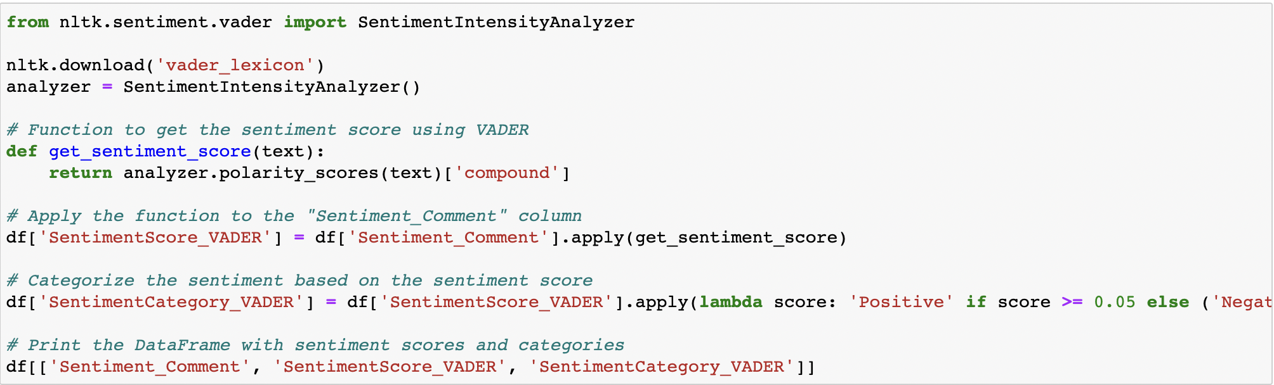

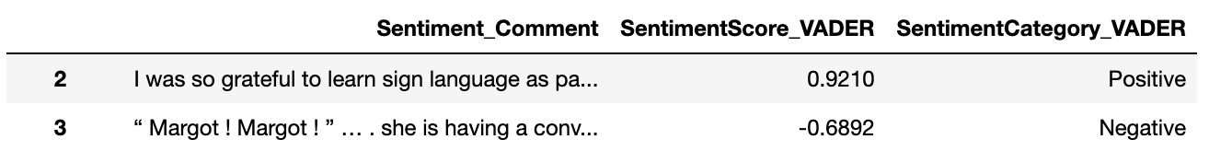

**Figure 24** *This is a Python code to build VADER sentiment analysis.*

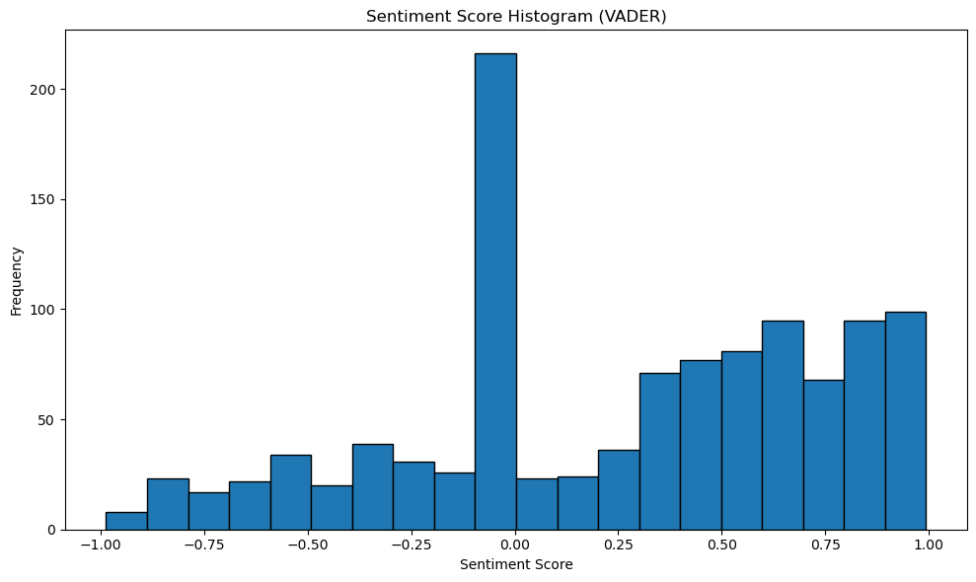

**Figure 25** *This is a histogram to show the VADER sentiment analysis score breakdown.*

Further investigation into the extreme ends of the sentiment spectrum revealed that VADER demonstrated remarkable success in precisely detecting positive and negative emotions. However, the predominance of dataset entries near the sentiment boundaries necessitates closer scrutiny and analysis. For instance, while the comment with the highest sentiment score was extensive, its most poignant sentence, "She's the main character and shows a lot of range in the movie, including every emotional moment near the end that made people cry," contributed significantly to the overall score. On the other hand, the comment with the lowest sentiment score, despite its length, featured the striking sentence, "No matter what, the end goal is to hate on women, which is why the hate on Margot Robbie being 'too old' is laughable," prominently influencing the overall negative sentiment. These findings suggest that VADER excels in discerning sentiments at the extremities but warrants in-depth consideration when dealing with sentiments concentrated around the boundary values.

TextBlob's sentiment classifier represents a pre-trained machine learning model proficient in analysing and categorizing the sentiment of textual content as positive, negative, or neutral based on the presence of specific words and phrases. While this model, trained using the movie reviews dataset, may yield more accurate outcomes when applied directly to movie-related comments, its development involved the utilization of Python's textblob and nltk libraries (Figure 26).

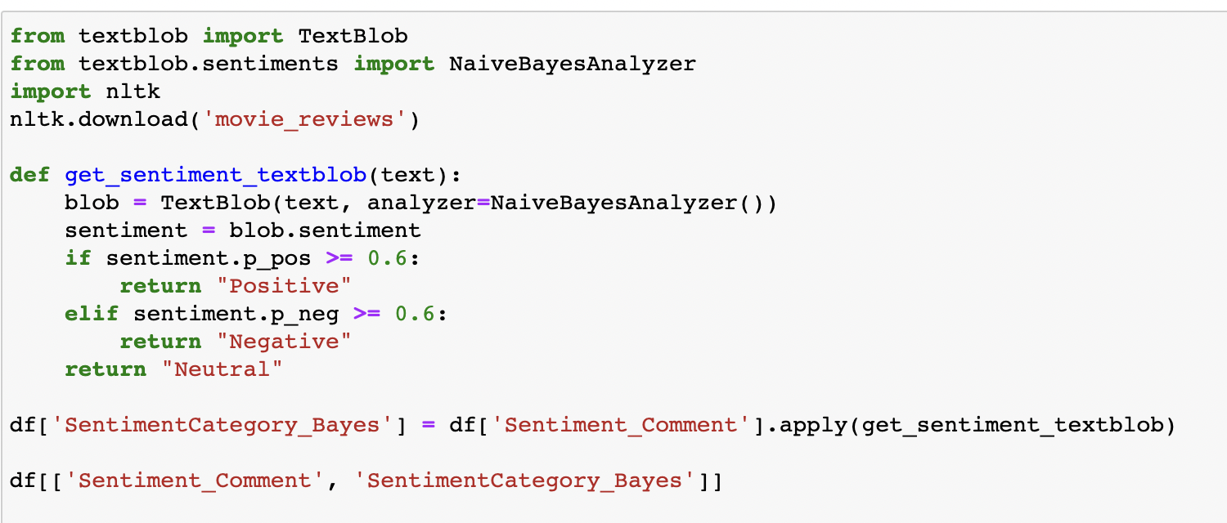

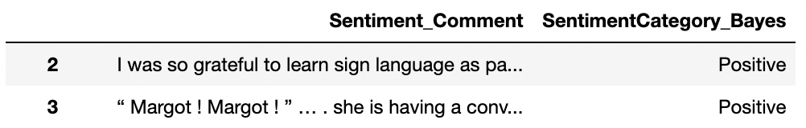

**Figure 26** *This is a Python code to build TextBlob’s sentiment classifier.*

Distinct from VADER, the TextBlob model generated separate sentiment scores for both negative and positive sentiments, and it is generally regarded as indicative of a particular emotion when it surpasses the threshold of 0.6. Consequently, precisely 536 comments have been identified as warranting different evaluations when juxtaposed with VADER's categorization.

It is essential to highlight that, despite its ability to produce multiple sentiment scores, the TextBlob model's categorization approach contrasts with VADER's single-score output. Consequently, their utilization and interpretation demand careful consideration to ensure meaningful insights are drawn from the sentiment analysis process.

Stanford University's SocialSent analysis is a sentiment analysis approach that operates on a corpus of 1900-2000 words, employing predetermined scores (https://nlp.stanford.edu/projects/socialsent/ accessed on 31 July 2023). The sentiment score is derived by summing the preassigned coefficients and then dividing them by the total number of words in the text (Figure 27). Upon conducting this analysis, it was observed that a significant proportion of the dataset resulted in sentiment scores proximate to 0 (Figure 28).

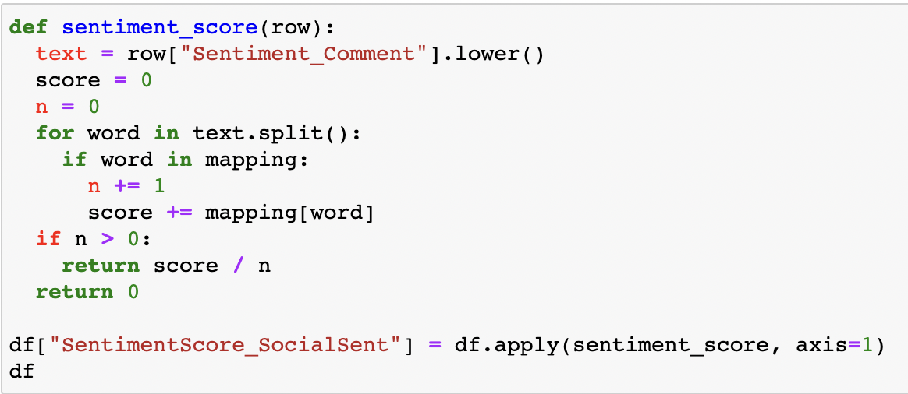

**Figure 27** *This is a Python code to build SocialSent sentiment analysis.*

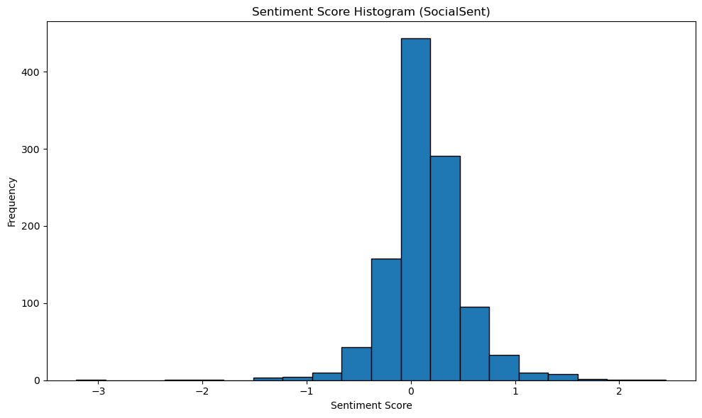

**Figure 28** *This is a histogram to show the SocialSent sentiment analysis score breakdown.*

As per the SocialSent analysis, the comment with the highest sentiment score was "Beauty Margot ❤️😘🌹," while the comment with the lowest sentiment score was "Sounds awful." Notably, while longer comments exhibited the capacity to generate higher sentiment scores in VADER, the SocialSent approach demonstrated the ability to yield more extreme sentiment scores for shorter comments.

This implies that the two sentiment analysis methodologies, VADER and SocialSent, diverge in their response to different comment lengths, potentially influencing the interpretation and effectiveness of sentiment analysis based on comment size. Consequently, these findings underscore the significance of considering the specific characteristics and peculiarities of each sentiment analysis technique to derive comprehensive and accurate insights from user-generated content.

Upon comprehensive evaluation of all three sentiment analysis methodologies, a notable degree of convergence was observed in their categorization outcomes (Figure 29). Notably, all three approaches yielded relatively higher positive sentiment evaluations, while exhibiting closely aligned results for neutral and negative sentiments.

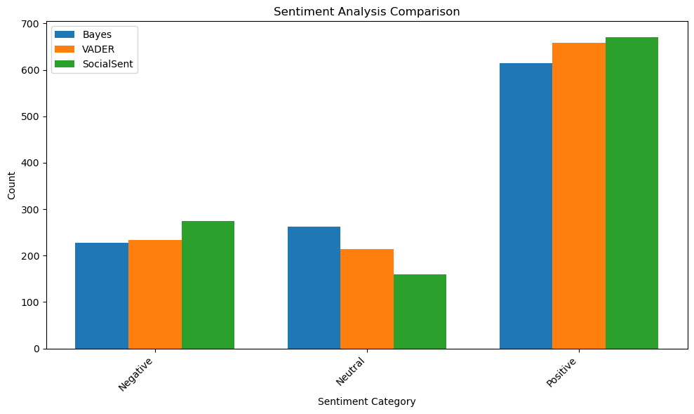

**Figure 29** *This is a bar chart to compare the sentiment category of VADER, TextBlob, and SocialSent analysis.*

When juxtaposed against a machine learning-based sentiment analysis model established using the NaiveBayesClassifier, SocialSent emerged as the most efficacious technique, achieving an impressive accuracy rate of 68%. Subsequently, TextBlob with NaiveBayes achieved a commendable accuracy rate of 56%, followed by VADER with 54%. These findings underscore the superiority of SocialSent as a more suitable model for the dataset under consideration.

The discernible disparity in accuracy rates between SocialSent and the other methods signifies the former's enhanced capability in capturing the intricate nuances of sentiment expressed within the dataset. Consequently, these outcomes hold crucial implications for the selection of an appropriate sentiment analysis model to derive optimal insights from user-generated content in this context.

# CONCLUSION

In this case study, Reddit comments related to Margot Robbie and her recent work in the film "Barbie" were analysed. A dataset of 1633 comments was collected and underwent rigorous data cleaning and pre-processing. The exploratory analysis revealed a consistent daily influx of comments, and the dataset exhibited heterogeneity with diverse contributions from various authors.

The topic model analysis using Latent Dirichlet Allocation (LDA) identified five distinct topics, encompassing discussions about Margot Robbie's performance, her portrayal of a character in the movie, opinions about the movie itself, evaluations of the movie's quality, and remarks about specific elements or scenes.

Three sentiment analysis methodologies, VADER, TextBlob, and SocialSent, were employed to assess the sentiments expressed in the comments. While all methods showed a higher proportion of positive sentiments, SocialSent emerged as the most accurate model for this dataset, achieving a notable accuracy rate of 68%.

However, improvements and further developments are recommended, such as increasing the dataset size for better topic modelling and sentiment analysis. Overall, the case study provided valuable insights into public perceptions and sentiments surrounding Margot Robbie and her recent film, "Barbie," but ongoing enhancements in data collection and analysis methodologies would lead to more robust and accurate conclusions.

references